**<https://commonwealthbeacon.org/opinion/we-need-to-confront-the-states-long-decline-in-student-achievement/>**

[**Opinion**](https://commonwealthbeacon.org/category/opinion/)

**We need to confront the state’s long decline in student achievement**

*Mass. scores are far below where they stood during the ed reform heyday of the early 2000s*

by [Charles Chieppo](https://commonwealthbeacon.org/author/charles-d-chieppo/) and [Jamie Gass](https://commonwealthbeacon.org/author/jamiegass/)

February 7,2025

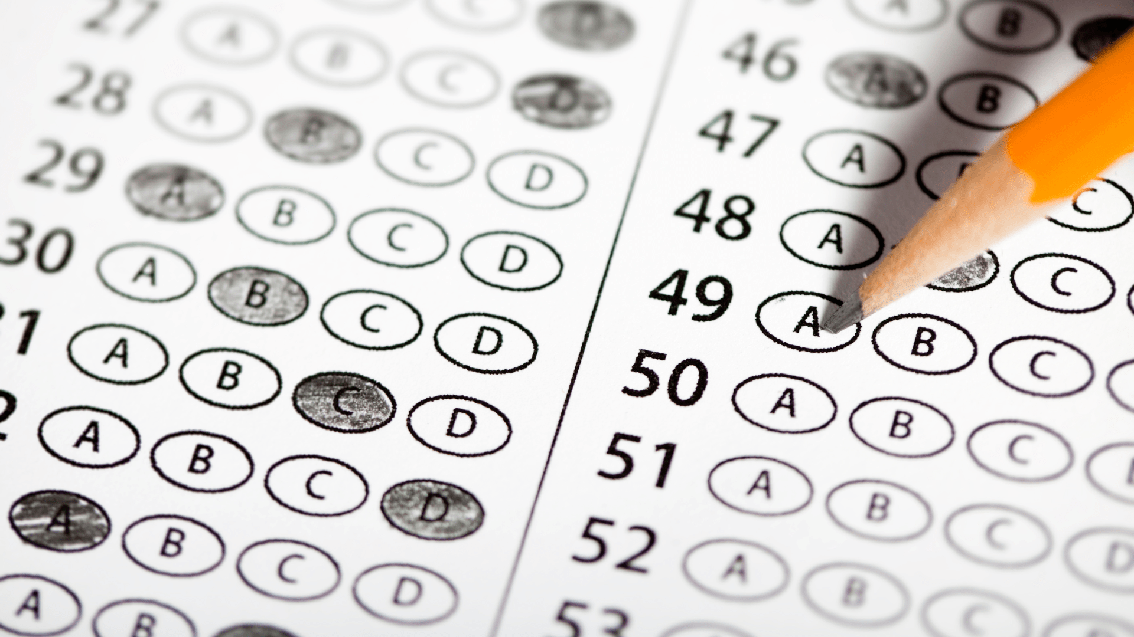

**IT’S UNFORTUNATE** that the Oscar nominations were just announced, because the recent performance by Gov. Healey, Lt. Gov Driscoll, and their education team at a press conference announcing another set of sobering National Assessment of Educational Progress (NAEP) results would have made them the odds-on favorite in the “Nero Fiddled While Rome Burned” category.

The governor and her team focused on inputs – their literacy initiative, raising the minimum per-pupil funding, increasing resources for special education – but they didn’t say that save for 4th grade math, this year’s results again showed no recovery of pandemic learning loss. This is particularly troubling because Massachusetts’ pandemic-related learning declines were among the nation’s steepest.

But the much bigger story that they ignored is that, all told, Massachusetts NAEP scores are down to where they were 20 years ago, and the results confirm those from state MCAS tests announced in September.

While we’re declining more slowly than some other states right now, we’ve been at it for longer. The deterioration in the quality of public education in Massachusetts had been underway for nearly a decade by the time the pandemic hit. Even if we were to recover pandemic learning losses, the Commonwealth would still be a far cry from its public education heyday in the first decade of this century.

Between 2011 and 2019, Massachusetts’ performance on NAEP math tests declined more than all but 17 states. In reading, we declined more than all but 14 states during that period.

The reason is simple. The way we deliver public education in Massachusetts – and across the nation – only works for wealthy and upper-middle-class students. To live up to its name, public education needs a radical overhaul.

At the NAEP press conference, Lt. Gov. Driscoll said, “we know what we need to do.”  That’s the saddest part of all — we know what works but have lacked the courage to implement it.

The reason we know is because Massachusetts was the place that got it right.  Beginning in the 1990s, the Commonwealth implemented sweeping reforms.  Funding for public education increased, and rigorous standards gave all students access to the kind of rich, knowledge-based liberal arts education that had previously been available only to the wealthy.

Because great public education is not one size fits all, reforms included the creation of charter public schools and upgrading both the academic and hands-on components of the Commonwealth’s vocational-technical high schools.

A Stanford University study found that Boston charter schools performed the best among the 41 urban charter sectors they reviewed, and multiple studies found that the schools enrolled an equal or greater share of low-income and special needs students than the surrounding district.

Many Massachusetts vocational-technical schools now outperform their sending districts and have dropout rates that are half that of comprehensive high schools. Other than educating a higher percentage of special needs students, their student population is representative of the districts from which their students come. Graduates are coveted by both higher education institutions and local employers.

National NAEP results show that the performance of white, Asian, and wealthy students is improving while Black, Latino, and low-income students fall further behind. But between 1998 and 2005, Massachusetts was among the top three states in narrowing achievement gaps.

After the 1993 passage of reform, Massachusetts SAT scores increased for 13 consecutive years. In 2007 and 2011, state students were competitive with their peers in the top-performing countries in the world on the highly regarded Trends in International Math and Science Study tests.

Massachusetts no longer participates in TIMSS. It’s not hard to figure out why.

As high standards, accountability and high-quality educational choices were compromised and ultimately eliminated over the past 15 years, the steady decline in NAEP scores was predictable. The elimination last November of passing MCAS tests as a high school graduation requirement will surely accelerate the decline.

Today, more funding is one of the only pieces of reform left standing.  Vocational-technical schools remain successful, but reform opponents are using methods similar to the ones they used on charter schools to undermine the voc-techs.

The Commonwealth’s leaders tout our status as the best-performing state; they don’t tell us it’s only because most other states are declining even faster than we are.

To be fair, the Healey-Driscoll administration didn’t cause the long unraveling of public education in Massachusetts. The question is whether they have the courage to take the bold steps needed to fix it.

*Charles Chieppo is a senior fellow and Jamie Gass directs the Center for School Reform at Pioneer Institute, a Boston-based public policy think tank.*